Google Coding
Create your own Google Logo

Login to CS first by clicking on the link below:

https://csfirst.withgoogle.com/en/home

You should see a page that looks like the image below.
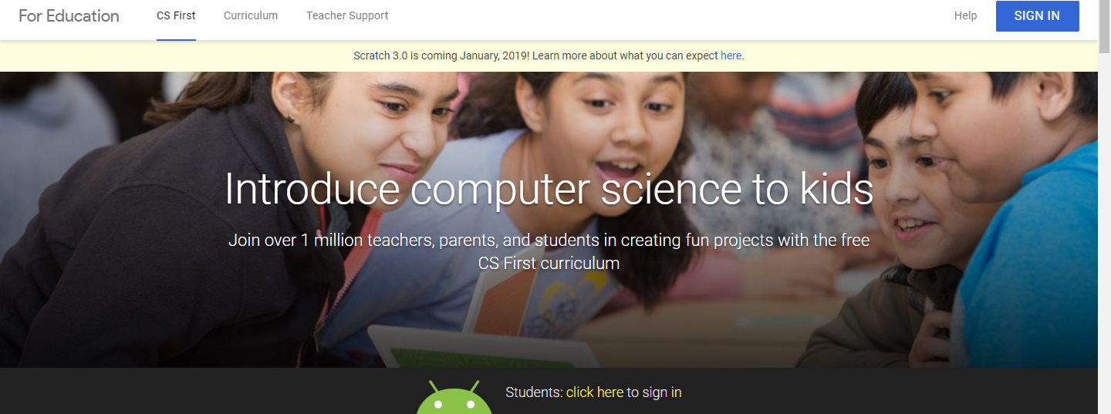

At the top right hand corner of the screen, you will see a blue “sign in” button. Click on that and sign in with your CSfirst username and password that you got when you did “animate your name.”

This is your club code: NN6VHD

Watch the videos and follow the directions.

It’s best to have “scratch” and “CSfirst” open at the same time so you can follow the directions from the video while you are watching it.

