Google Coding
Animate a Name

Login to CS first by clicking on the link below:

https://csfirst.withgoogle.com/en/home

You should see a page that looks like the image below.
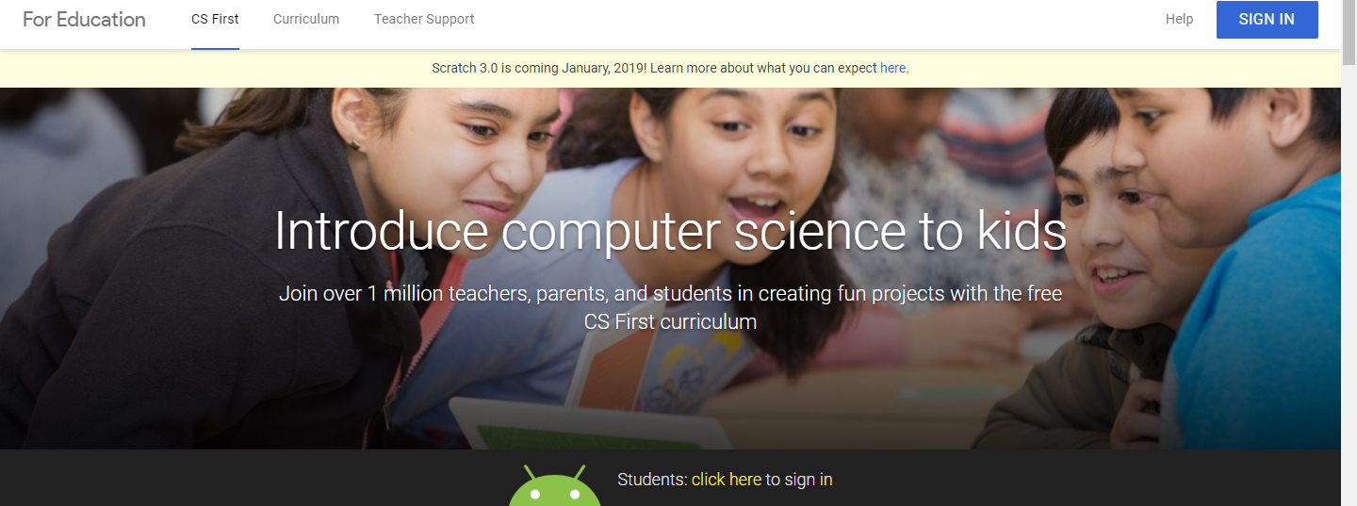

At the bottom center of the screen, click on “CLICK HERE” (in yellow)

You are a new student so click on “ENTER CLUB CODE” in blue
This is the code you will enter: PCYMTS

The computer will ask you a couple of questions to which all of the answers are “YES”
School? YES
Club name: Animate a Name? YES
Do you need a CS username and password? YES

WRITE DOWN OR TAKE A PICTURE OF THE USERNAME AND PASSWORD THAT THE PROGRAM GENERATES FOR YOU.

Click “I’m Done” (blue button)

Now you need to login with the username and password that you just wrote down or took a picture of.

Press “PLAY” on the “Animate” a Name Video. Listen to the video and take notes if you have to.

After watching the video click the “starter project” link and it will open “scratch” in a new tab. You will need to “join scratch” and sign up with a username (not your real name) and password. WRITE IT DOWN

Click “Remix” and title you project with the name you are going to animate

Return to the csfirst tab or show scratch and the video at the same time by holding down on the tab at the top and dragging it to your desktop.

Watch the videos to learn how to Animate your name.

Animate your name in by coding!

