Name _______________________________________________ Date _____________ Hour _____________
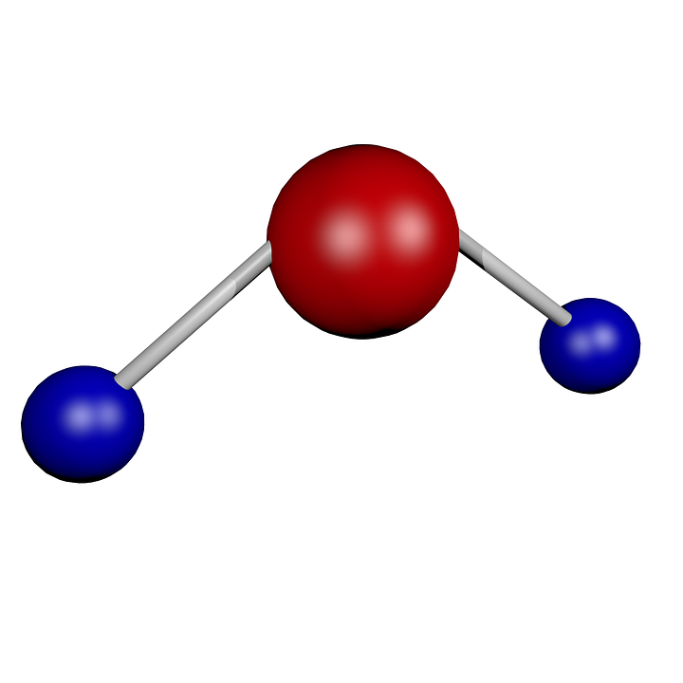 Exploring Molecules 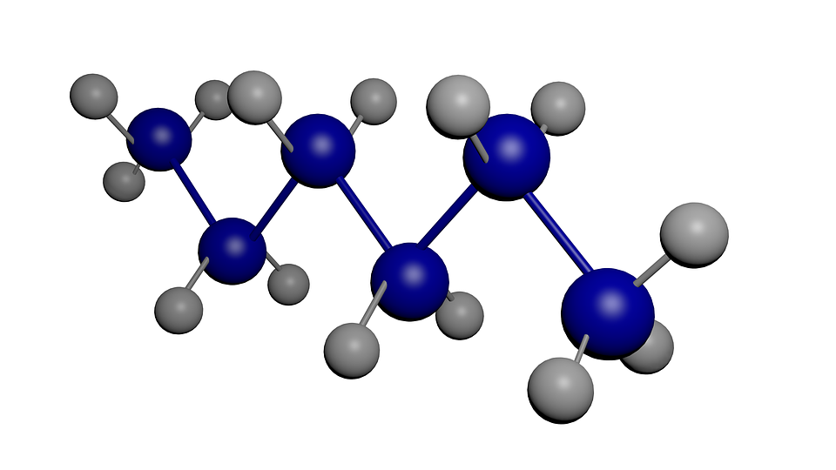
- Build ‘Em: http://nanospace.molecularium.com/attractions/build_em/
Click and drag your atoms to build the molecule in the key in the top right hand corner. When it’s done correctly, the bar on the right hand side of the box will fill up completely. You can also hold down the molecule and move your mouse to get a 3-D look at the molecule. When the bar on the right is filled, draw the molecule below on your paper.

1.Water  H  H  O | 6. Benzene  DO NOT DRAW BUT BUILD ON COMPUTER
2. Ethanol Draw | 7. Aspirin  DO NOT DRAW BUT BUILD ON COMPUTER
3. Propane Draw | 8. Vitamin C  DO NOT DRAW BUT BUILD ON COMPUTER
4. Butane Draw | 9. Fructose  DO NOT DRAW BUT BUILD ON COMPUTER
5. Acetone  DO NOT DRAW BUT BUILD ON COMPUTER | 10. Caffeine  DO NOT DRAW BUT BUILD ON COMPUTER

2. Atomatic: http://nanospace.molecularium.com/attractions/atomatic/
Record your score and molecules built for the first 5 levels.

Level | Score | Molecules
1
2
3
4
5

4. Mission To Bond: http://nanospace.molecularium.com/attractions/mission_to_bond/

5. Find out why diamonds and graphite are both made of carbon but are completely different. Explore this website: Carbon Is Incredible: http://nanospace.molecularium.com/attractions/carbon_is_incredible/ and watch this video: Materials World: https://youtu.be/sWWuxYXcmtM

Explain why diamond and graphite are both made of the same element carbon but are completely different.

________________________________________________________________________________________

________________________________________________________________________________________

________________________________________________________________________________________

________________________________________________________________________________________

________________________________________________________________________________________

6. Play the Periodic Memory game. Enjoy!! :)
http://nanospace.molecularium.com/attractions/periodic_memory/

