Pure substances
Pure substances are defined as substances that are made of only one type of atom or molecule. The purity of a substance is the measure of the extent to which a given substance is pure.
Images of Pure substances:
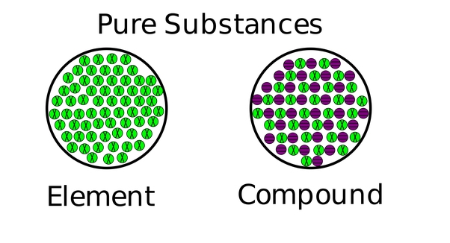

Every combination of atoms is a molecule. A compound is a molecule made of atoms from different elements. All compounds are molecules, but not all molecules are compounds.
Water is a molecule but also a compound.
Oxygen Gas is a molecule but not a compound because it is made up of 2 of the same atoms.

